REPORT FILE FOR BANK WEB APPLICATION OF RAJAT

FLOW CHART

1. USER_LOGIN PAGE:-

When the existing customer opens the web application they land on the home page from where they can login to their NetBanking portal. Using their user id and Password.

Here the LoginId is stored as a STRING and Password is the Integer value.

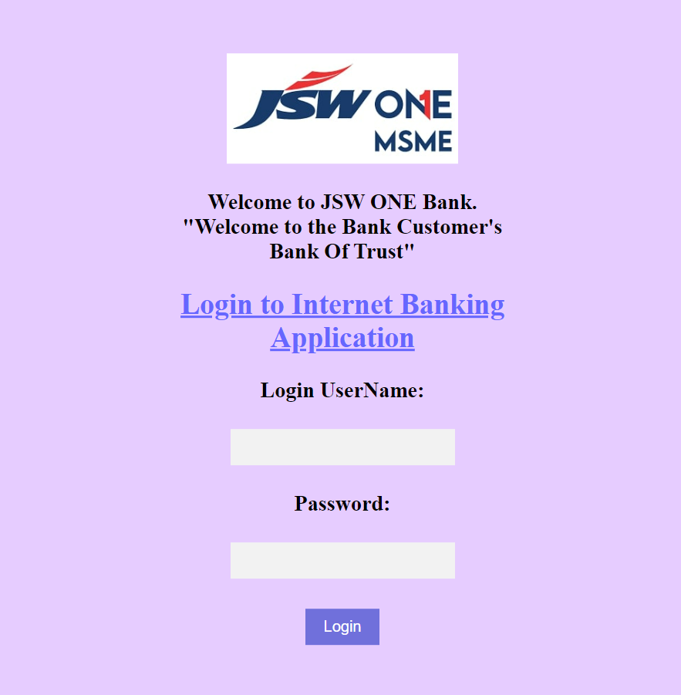

SIGNUP

When a new consumer login in the bank web application he can create his Username and Password .

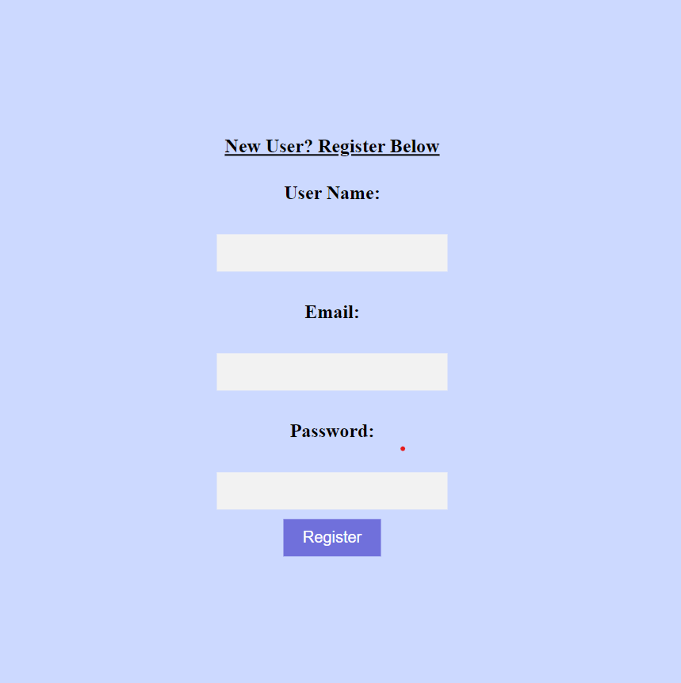

After Loging in the Customer lands on the home page where he can perform all the functions below.

1.CREDIT AMOUNT

2. DEBIT AMOUNT

3. CHECK BALANCE

4. LOGOUT

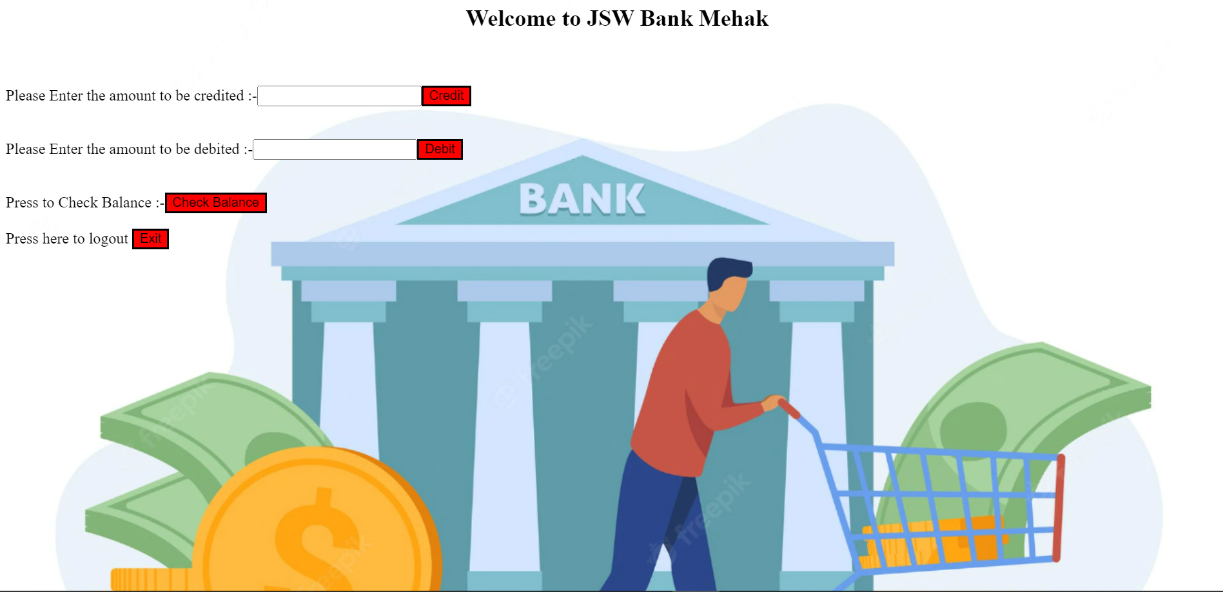

1. WORK FUNCTION OF CREDIT FUNCTION

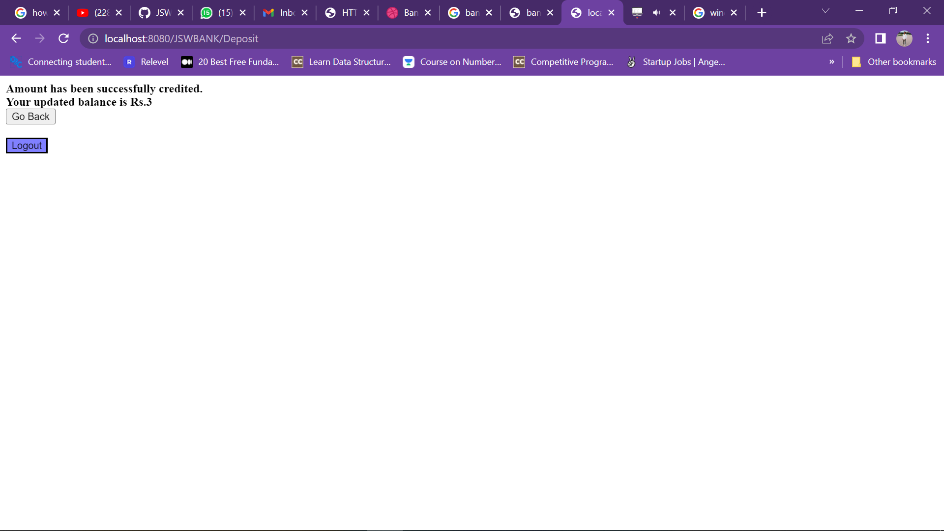

When the customer deposits the money into the bank the data is stored in the database and it real-time updated. So when we check the balance it will be updated and stored .

1. WORK FUNCTION OF DEPOSIT FUNCTION  
   

After credit when the person wants to debit the certain amount of money he can debit it and it will be updated in database.

NOTE: In credit , the addition operation is working in the table and in Debit operation the subtraction operation is working. And both the operation is being stored in the table.

1. CHECK BALANCE

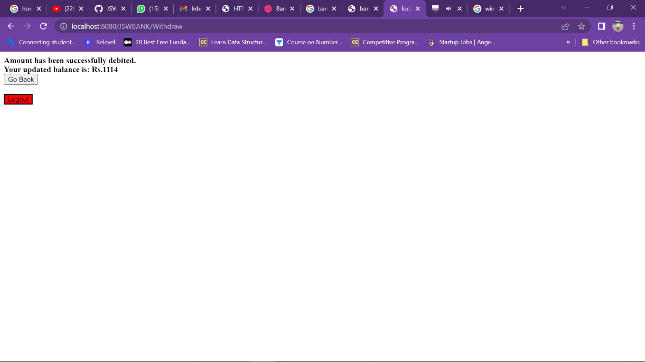

So whatever the amount is being credited or debited it get processed and updated and stored in Database and we can check the balance stored.

NOW THE SNIPETS OF ALL THE CODES IN THE FOLDER AND ALL THE SERVLETS EXPLAINED BELOW

1. HTML LANDING PAGE

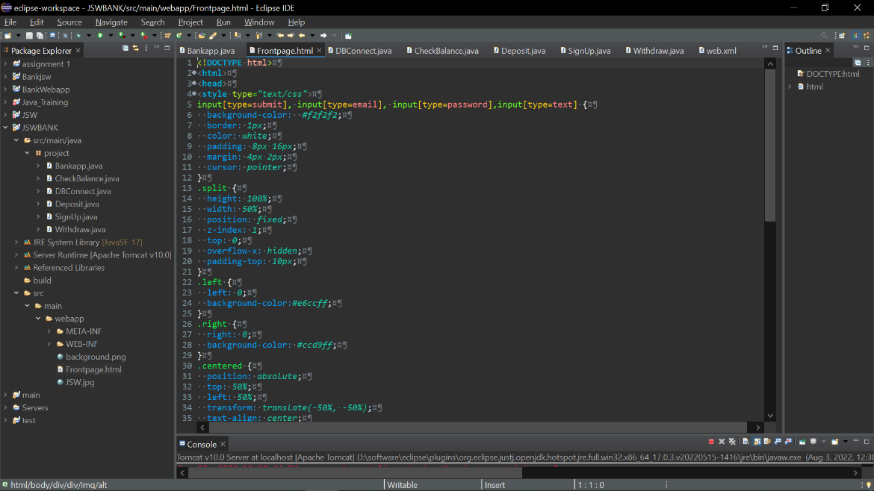

This is the HTML Page designed and it’s the landing page when the user opens up the web app.

1. The LOGIN SERVLETS.

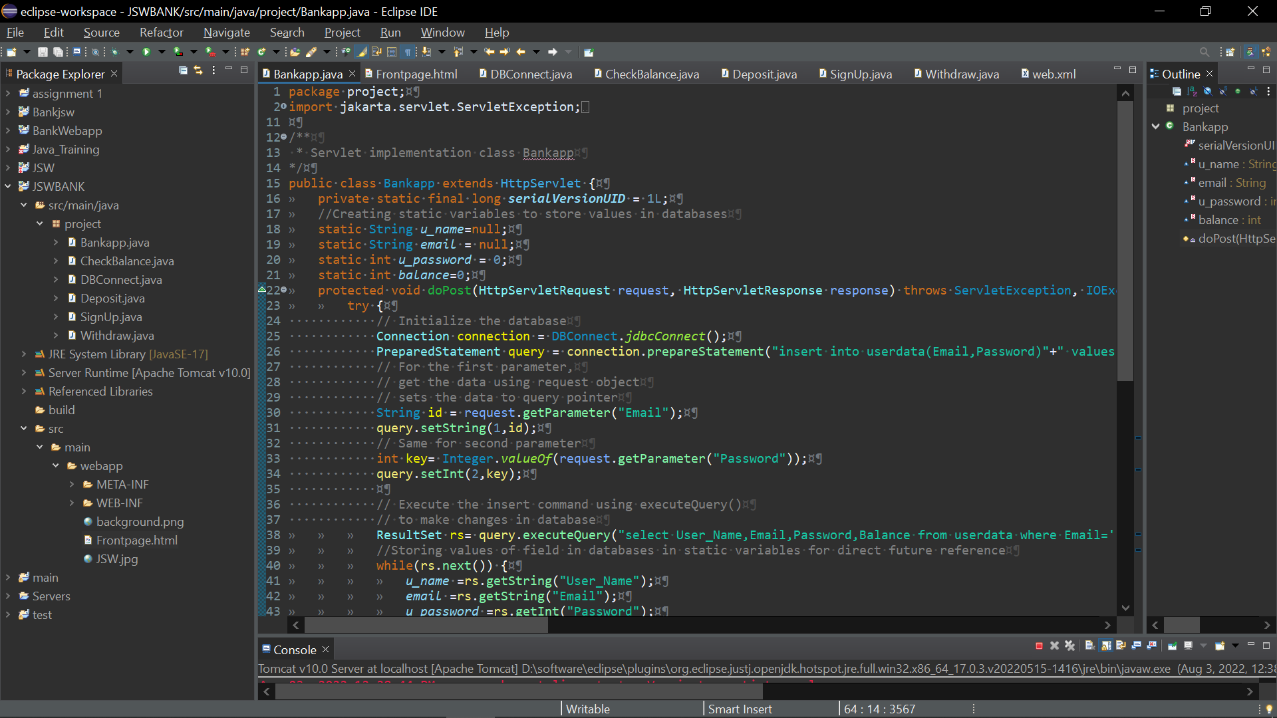

1. CHECK BALANCE SERVLETS

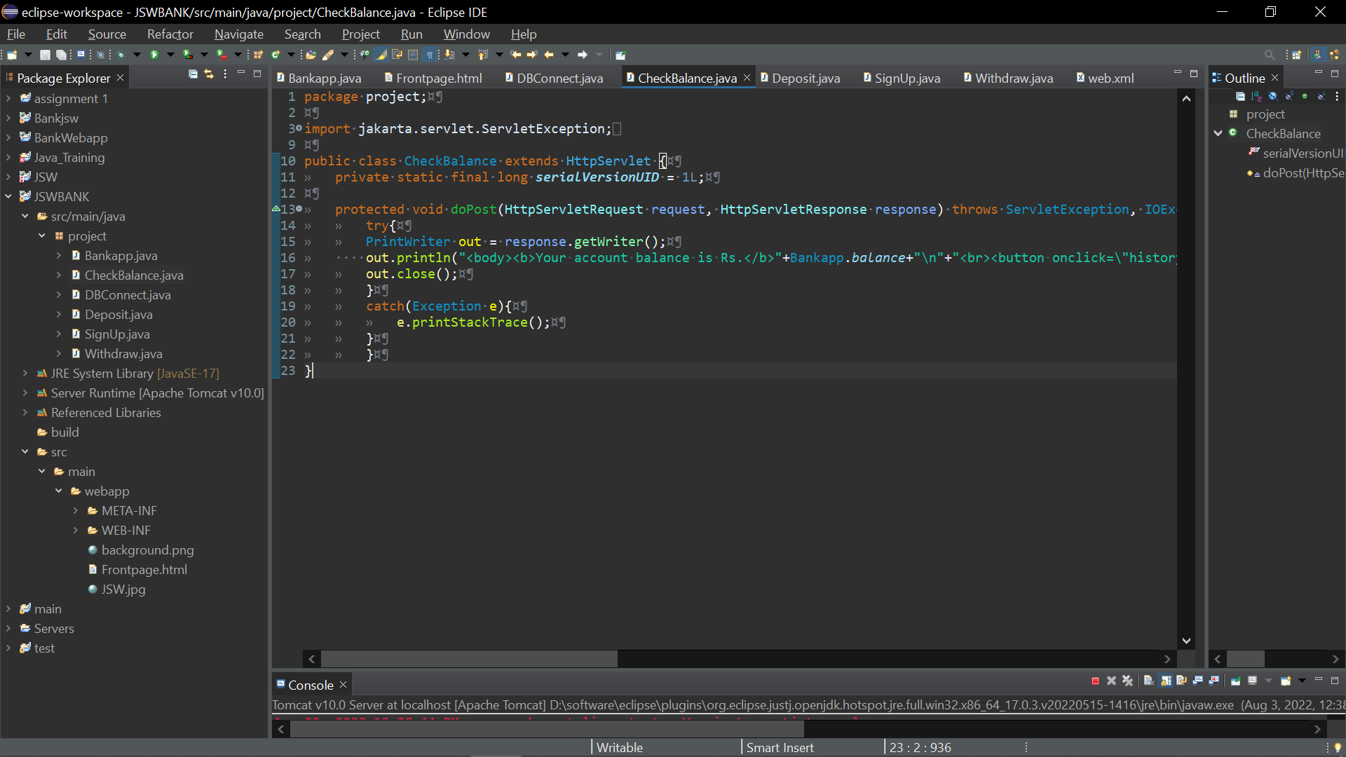

1. DATABSE CONNECTION SERVLET  
   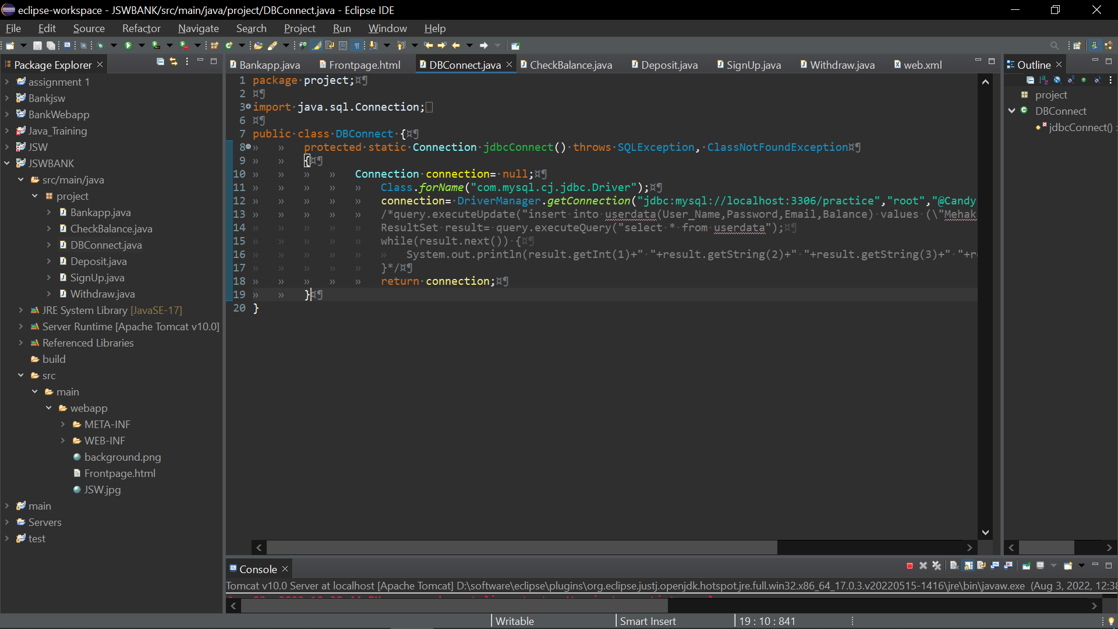

5.DEPOSIT SERVLETS

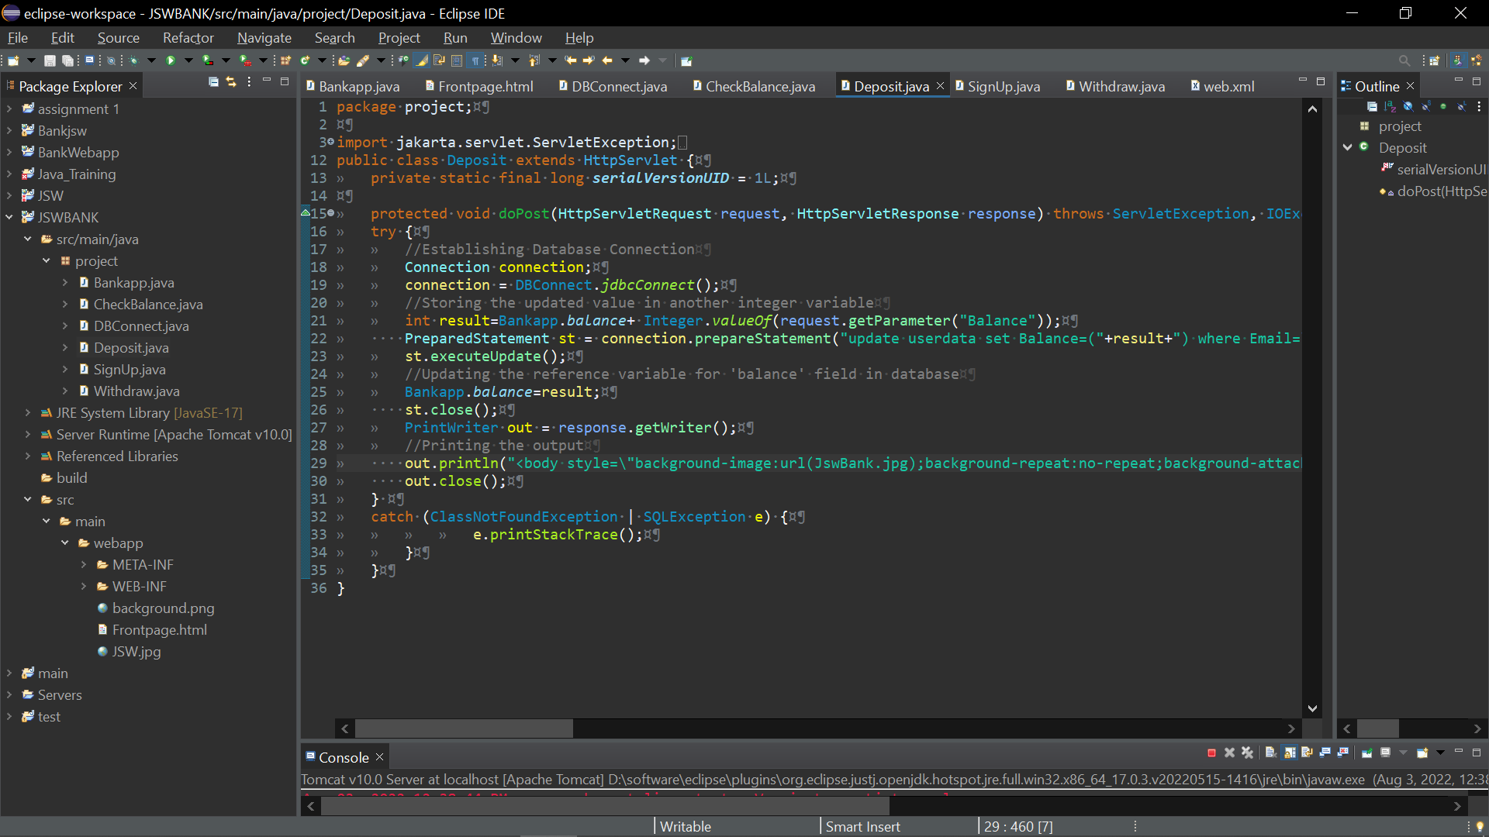

6. WITHDRAW SERVLETS

